PUBLICITY COORDINATOR APPLICATION PACK SPRING 2024
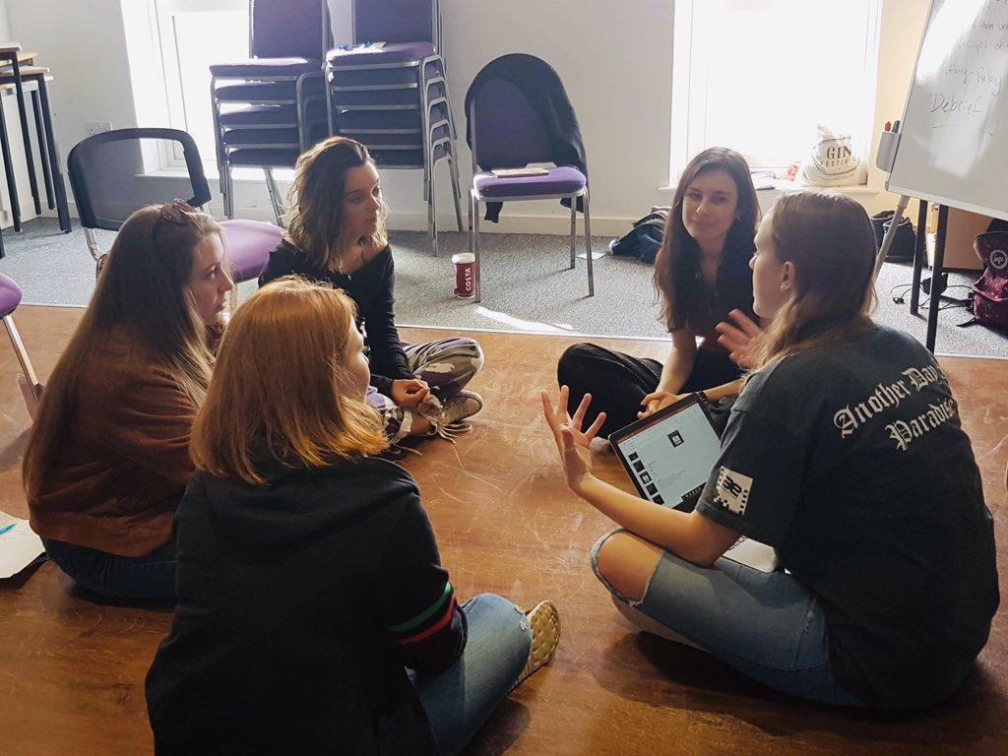
Thank you so much for considering becoming a member of SKIP. We are undergoing an exciting process of change and development so your contribution to SKIP will be significant. We are a small and hardworking but friendly and supportive team - we can’t wait to have you on board!

ABOUT THE CHARITY
We are a volunteer-led, UK-based global health charity focusing on child mental health.
After the Coronavirus pandemic, SKIP underwent a period of pausing, reflecting and reimagining our organisation structure and activities. We are now in the process of research and development for our new pilot programmes. We are also in the process of re-branding and coming up with a new name!
You can find out more about this process and what SKIP used to be on our website: https://www.skipkids.org.uk/
Our vision:
For all children to be cared for and supported in accessing the basic rights of health, welfare and education within their communities.

For future professionals to have the awareness, ability and motivation to influence and contribute to global development.

Our values:
- Empowering
- Sustainable
- Inclusive

Our work:
We deliver education-based projects which are intended to improve child health and welfare locally and internationally. Our current programme of work is child mental health.

Our projects within this programme will be carefully designed, evidence-based and continually reflected upon for improvement. They will be tailored to local areas and based on needs, ensuring we do not take a ‘one size fits all’ approach.

Any interventions will be educational and aimed at increasing understanding of topics and raising awareness - they will not be medical or clinical in any way.

Alongside these projects, we will also run national programmes that include global health training, personal and professional training for volunteers, and advocacy work.
All projects will be delivered by well-trained and supported volunteers, in close collaboration with partner organisations, such as grassroot charities, local-based organisations, youth clubs and schools.

ABOUT THE PUBLICITY ROLE AND RESPONSIBILITIES
Join us in this extremely exciting phase to help redesign and reimagine a global health charity for the future.
We are seeking a motivated individual to join our team of volunteers in a publicity capacity. The successful candidate will be responsible for the production and distribution of a monthly newsletter detailing the charity’s current work alongside the creation of content for our social media outlets.
You will be working alongside our Trustee lead for Communications & Marketing by taking an operational lead on the charity’s public communications under their strategic guidance
We are welcoming to applicants of all backgrounds. We are particularly pleased to welcome applications from people with lived experience of mental health issues.

KEY INFORMATION
- Supervisor: Dr Jacob McSweeney (Trustee Lead for Communications & Marketing)
- Length of time: Initial term of 6 months
- Voluntary role. Expenses may be covered for travel and training.
- Commitments:
  - Produce and oversee a monthly blog update uploaded to the SKIP website;
  - Take operational lead over our social media platforms (including but not limited to content creation, audience building and engagement management);
  - Develop publicity content for public updates including recruitment cycles, milestones and achievements;
  - Ensure our values are upheld at all times across our social media platforms;
  - Aim to respond to direct emails within 7 days and notify team in advance if unavailable for more than a week;

PERSON SPECIFICATION AND ELIGIBILITY
Essential | Desirable
Knowledge  - A commitment to the aims, objectives and values of the organisation.  - Interest in global health, mental health and/or volunteer-led organisations  - Understanding of major social media platforms  Experience  - Content creation  - Use page/creator tools across social media platforms  - Working with volunteers  Skills & abilities  - Time management skills  - Basic IT skills  - Basic graphic design  - Excellent teamwork and communication skills  - Creative thinking | Knowledge  - Of mental health issues in children  - Of global health and sustainable development  - Of audience engagement techniques  - Of Search Engine Optimisation (SEO)  Experience  - Management of charity/non-profit/social action media pages  - Blog writing  Skills  - SEO  - Proficient in the use of Canva, Photoshop and Squarespace

All SKIP Volunteers must be 18 or above by the date their term is to start.

HOW TO APPLY
- Complete the application form below.
- Send your completed application form and an anonymised CV (no more than 2 pages) to trustees@skipkids.org.uk with the subject “Publicity Role”
- Candidates without a completed full application form and CV will not be considered.
- Deadline to apply: 23.59 BST Sunday 7 April 2024
- Interviews will be held during w/c 15 April online.
If you have any questions about the SKIP Publicity role, about the application process or if you need any adjustments made when applying, please email jacob.mcsweeney@skipkids.org.uk

APPLICATION FORM
Question 1: Please provide a description of your motivation for applying for this position (max 400 words).
Click or tap here to enter text.
Question 2: Detail what knowledge, experience and skills you can bring to the role (max. 400 words).
Click or tap here to enter text.
Question 3: Using one example, please briefly outline what considerations and precautions you would take before publishing content to the charity website / social media platforms. (max. 400 words)
Click or tap here to enter text.

Scenario: You are working on the latest monthly update blog and seeking information/updates from our Mental Health Programme team. Despite emailing twice over the last three weeks, you are still yet to receive any reply or information. The monthly blog is due to be released in a week’s time.
What do you do:
a) in the short term? (max. 100 words)
b) in the longer term to ensure situations like this do not arise again? (max. 100 words)
Click or tap here to enter text.

